**Experiment 2**

**Akshat Singhal**

**500082498**

**R214220118**

**Aim: - Working with Docker (basic commands)**

Step 1: - Search for a Redis image on Docker hub

Command: -**docker search redis**

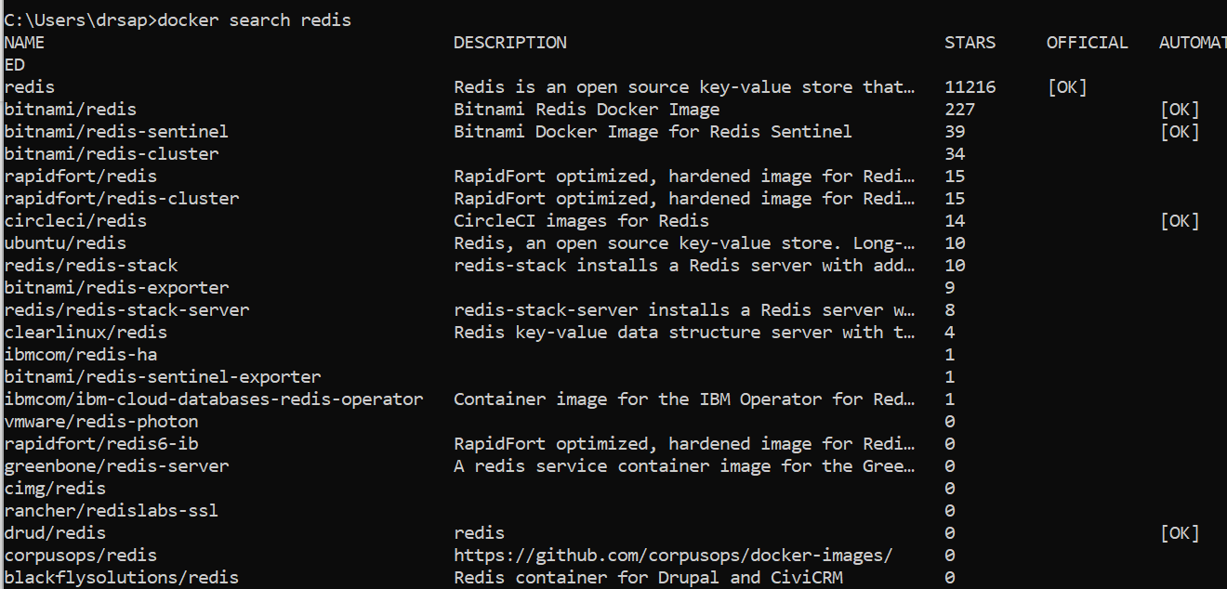

Step 2: - Run docker container of Redis image in the background

Command: -**docker run –d redis**

Command: - **docker ps**

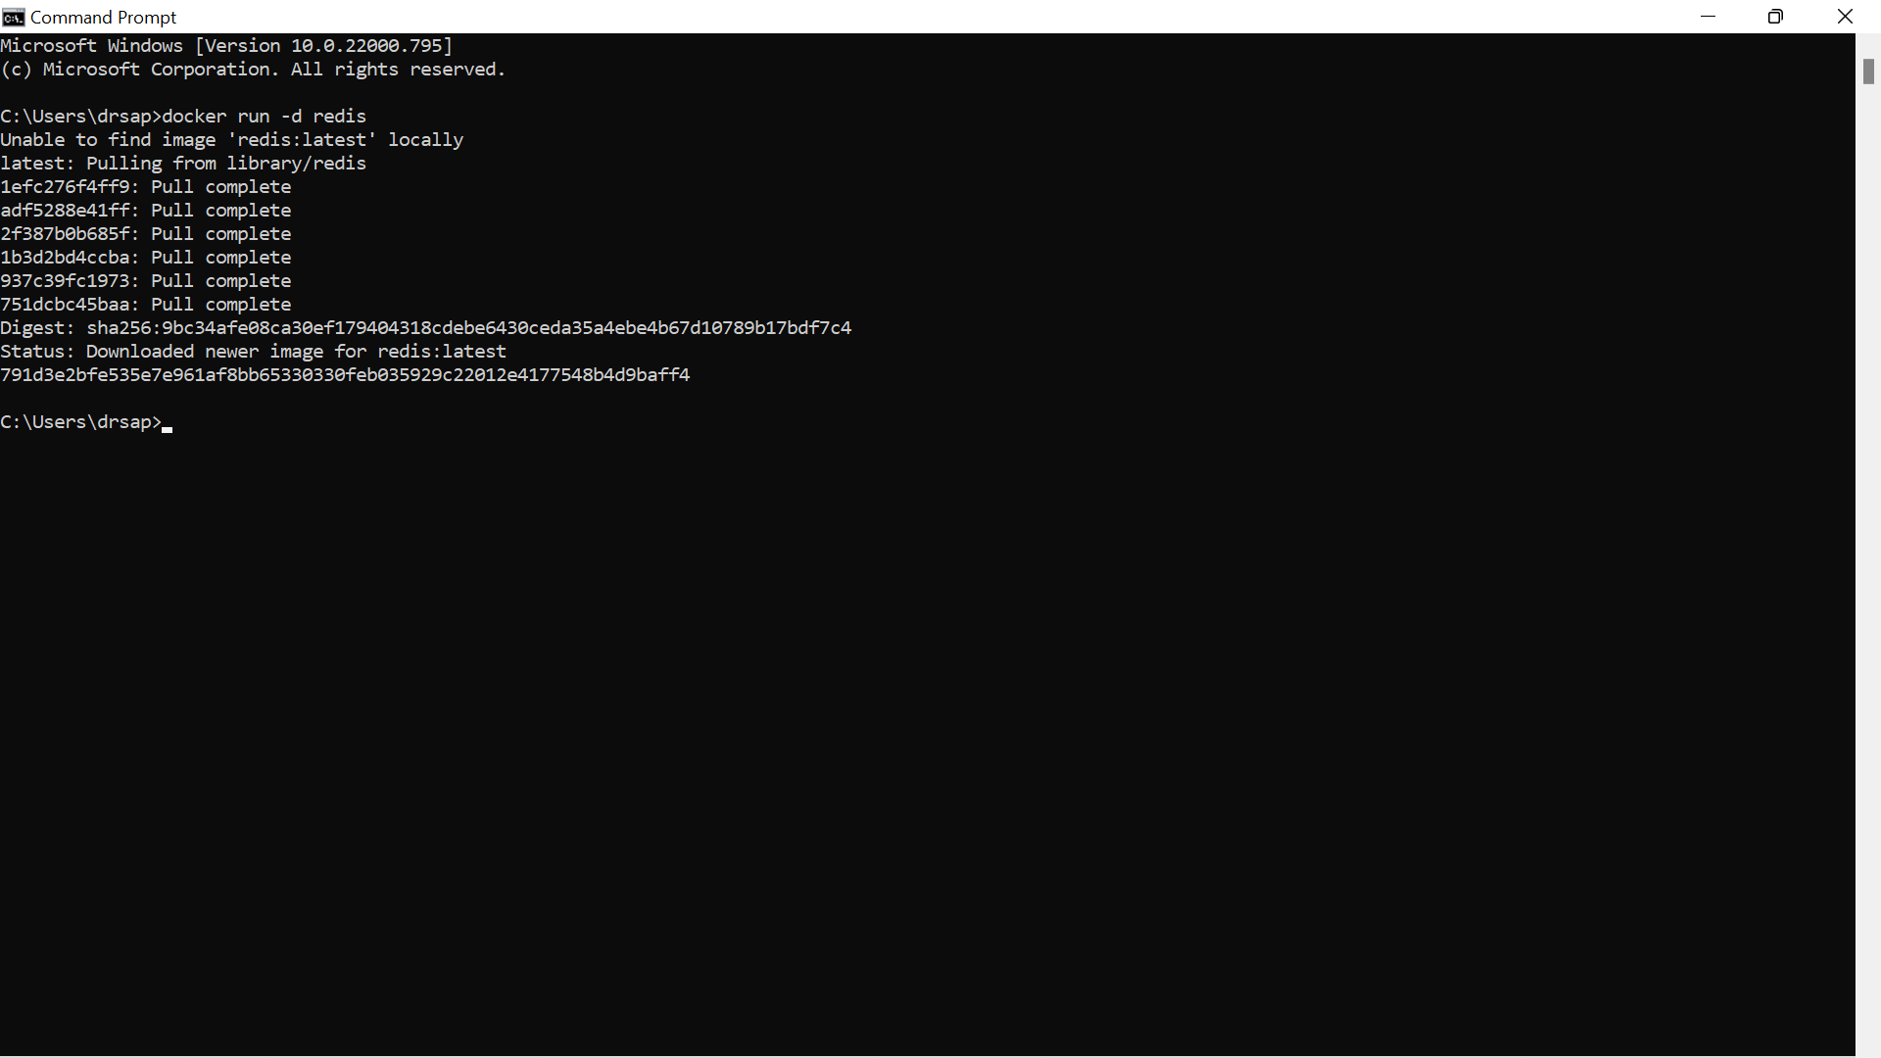

Step 3: - Run Docker PS and Docker PS –a

Command: - **docker ps -a**

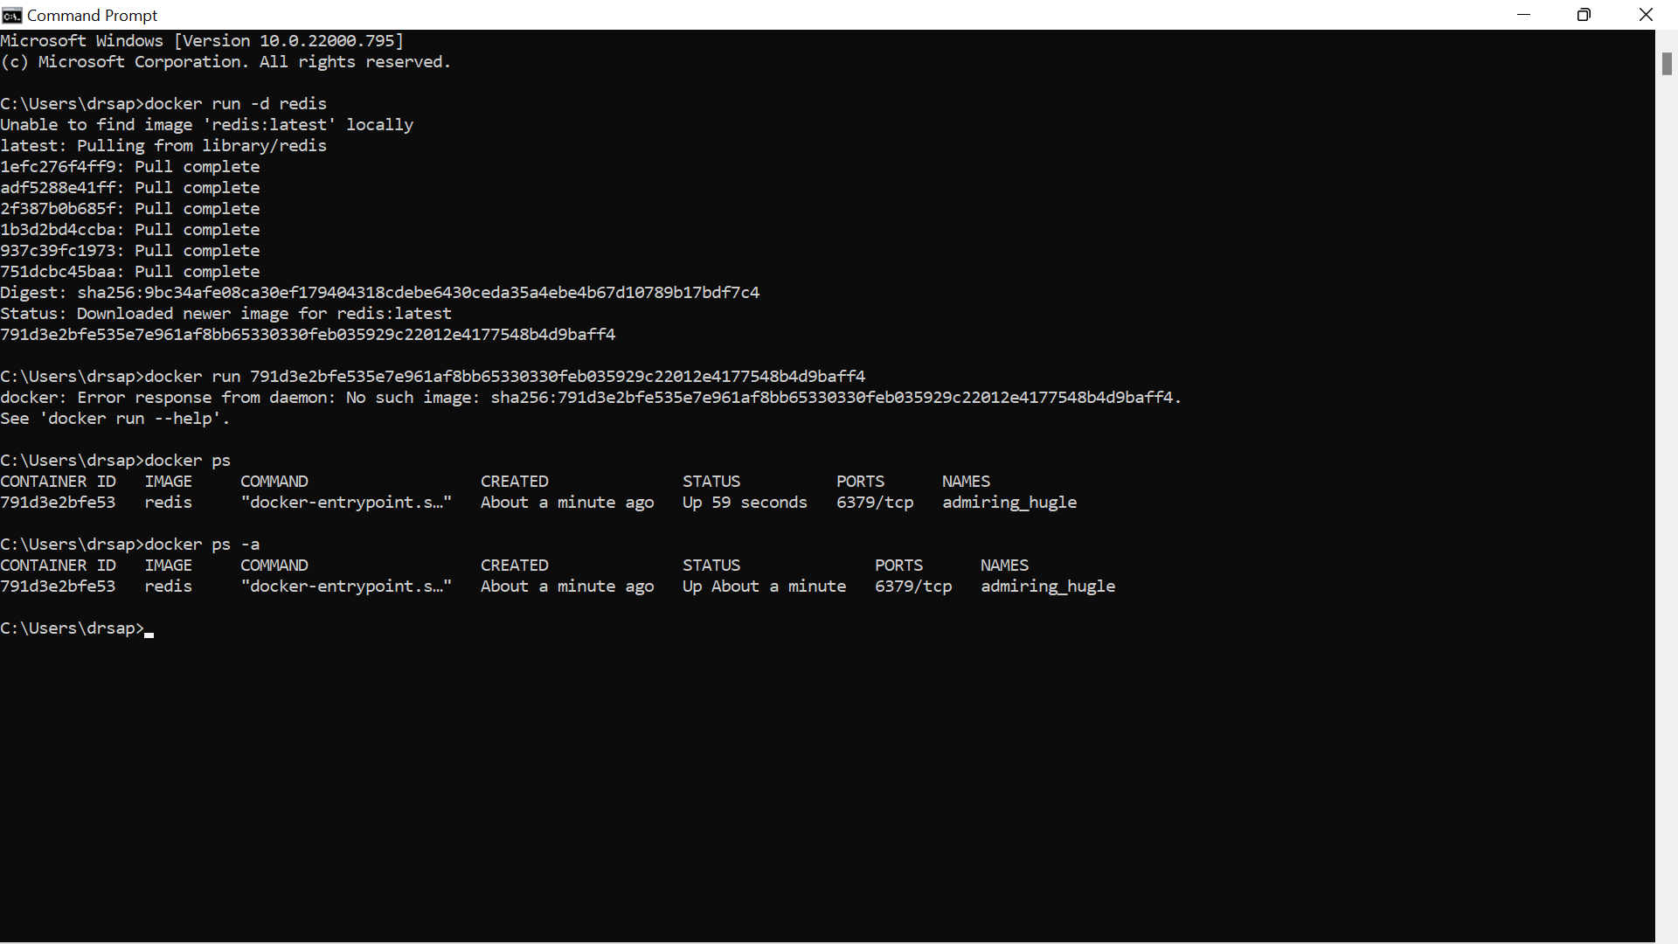

Step 4: - Run Docker Container and take its console

Command: -**docker run –it redis /bin/bash**

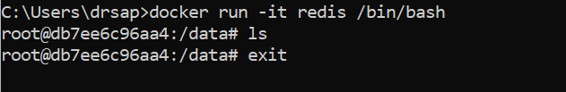

Step 5: -Create a Docker Volume and connect it

Command: -**docker run –it –v myvol:/data redis /bin/bash**

